Ch.3 lab 1 Exercises

# Task 1

The university bookstore has a Kilobyte Day sale every October 24 (10.24), giving an 8 percent discount on all computer accessory purchases if the price is less than $128, and a 16 percent discount if the price is at least $128.Write a program that calculates and prints the price after the discount.

***Sample Output1:***

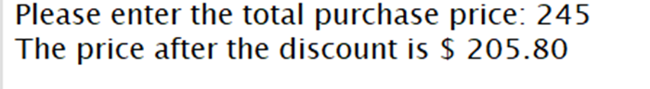

***Sample Output2:***

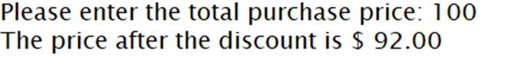

|  |
| --- |

|  |
| --- |

# 

# Task 2

Write a program that calculates the shipping cost as shown in the slide.

***Sample Output1:***



***Sample Output2:***

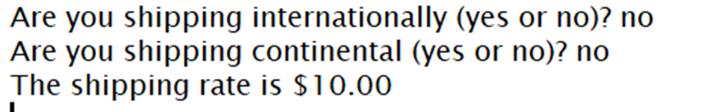

***Sample Output3:***



  
  

  
  

  
  

  
  